**INTRODUCTION:**

A database management system (DBMS) is system software for creating and managing databases. A DBMS makes it possible for end users to create, protect, read, update and delete data in a database. The most prevalent type of data management platform, the DBMS essentially serves as an interface between databases and end users or application programs, ensuring that [data is consistently organized and remains easily accessible](https://searchdatamanagement.techtarget.com/tip/Why-organizations-need-a-solid-data-governance-strategy).

A vehicle management system is a term that encompasses smart, forward-thinking usage and tracking of fleet movements. A VMS gives you a transparent view of metrics by turning each vehicle into a data node, complete with login capabilities and much easier to use. This system is a powerful tool, which can be implemented to improve fleet efficiency, manage drivers’ performance, track vehicle data, and integrate it into a company’s ERP.

**SHORT DESCRIPTION ON THE PROJECT:**

My project ‘Transport Management System’ is based on database, object oriented. As there are many areas we keep the records in database for which here Oracle DBMS has used that is one of the feasible and easiest to keep our information.

The project ‘Transport Management System’ contain the information of bus and train mainly that represents the systematical use and database of other transport as well. The schema of bus consists of:

* Buses:(bus_no, bus_regNo, capability, model, date_of_bought, insurance_status, insurance_date, insurance_expiry)
* Employee: (Employee_no, Surname, First name, Last name, Telephone, Address, Birth Date, Gender, Designation, Email)
* Passenger: (Pass_no, Pass_name, Address, Telephone, Date_of_travel, Depot, To_place, pay_status, booked_status)
* Route: (Route_no, route_name, depot, destination, distance, Fare_charged)
* User: (Name, category, password,username)
* Validator: (Bus_no, Driver_no, route_no, date_scheduled, trip_no)
* Booking: (booking_no, pass_no, pass_name.bus_regNo, seat_no, date_of_travel, time_of_travel, pass_from, destination, amount) Foreign keys: ( Pass_no, Bus_regNo)
* Payment: (Payments_no, Pass_no, pass_name, payment_mode, payment_date, paid_amount, received_by) Foreign Keys:( Pass_no)
* Schedules: (Bus_no, bus_regNo, route_no, route_name, empNo, Driver_name, date_scheduled, Dept_time) Foreign Keys:(bus_regNo, route_no, empNo)
* Trips: (Trip_no, bus_regNo, route_no, Schedule_date) Foreign Keys:(bus_regNo)

Here the information of buses are shown. From this table we can know about the bus company , employee works on that company, passenger and the payment details. Which route can be used is also mentioned here. From this database ,the user can easily find any kind of information is required.

We have done the same process fo collecting the informations for train.

* Train:(train_no, train_regNo, capability, date_of_bought,)
* Employee_train: (Employee_no, Surname, First name, Last name, Telephone, Address, Birth Date, Gender, Designation, Email)
* Passenger_train: (Pass_no, Pass_name, Address, Telephone, Date_of_travel, Depot, To_place, pay_status, booked_status)
* Route_train: (Route_no, route_name, depot, destination, distance, Fare_charged)
* User_train: (Name, category, password,username)
* Validator_train: (train_no, Driver_no, route_no, date_scheduled, trip_no)
* Booking_train: (booking_no, pass_no, pass_name,train_regNo, seat_no, date_of_travel, time_of_travel, pass_from, destination, amount) Foreign keys: ( Pass_no, train_regNo)
* Payment_train: (Payments_no, Pass_no, pass_name, payment_mode, payment_date, paid_amount, received_by) Foreign Keys:( Pass_no)
* Schedules_train: (Train_no, train_regNo, route_no, route_name, empNo, Driver_name, date_scheduled, Dept_time) Foreign Keys:(train_regNo, route_no, empNo)
* Trips_train: (Trip_no, train_regNo, route_no, Schedule_date) Foreign Keys:(train_regNo)

All the informations about trains are included here. All the speciality goes same as buses.

**ER Diagram:**

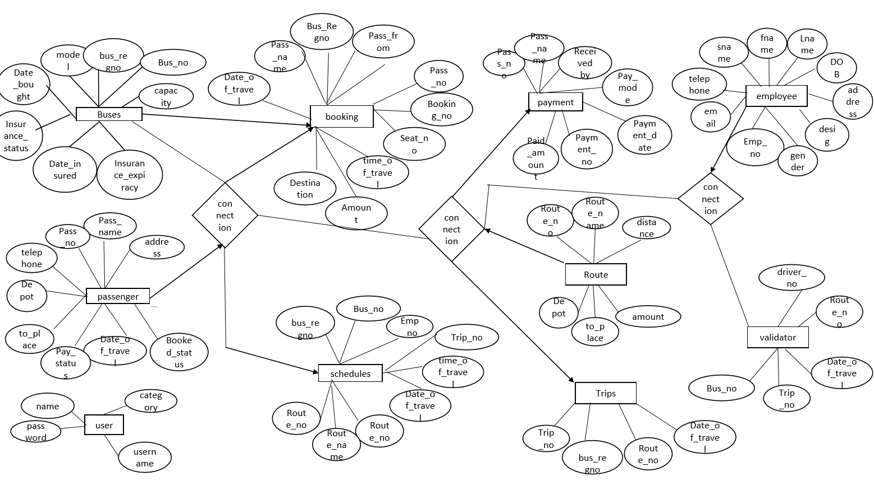

Figure-01: Entity Relationship Diagram of transport management system

SCHEME DIAGRAM:

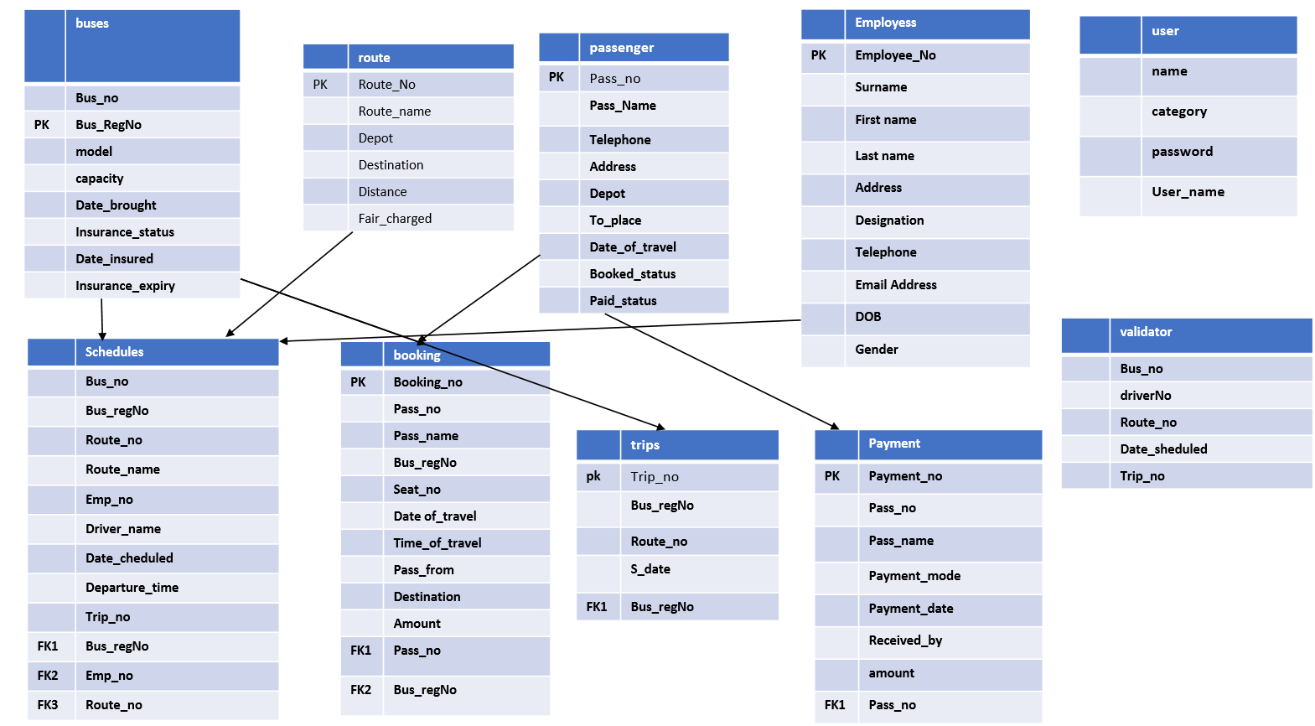

Figure-02: Schematic Diagram of transport management system (bus as transport)

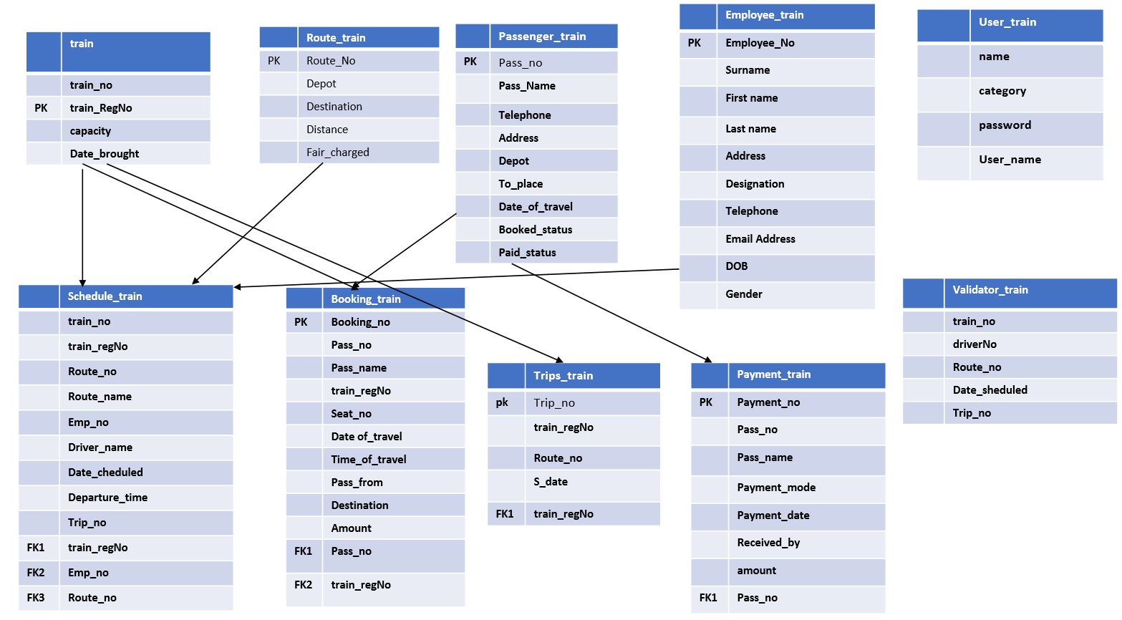

Figure-03: Schematic Diagram of transport management system( train as transport)

**Discussion:**

In this project , a database management system of a transport has been developing using SQL.

Here the data are stored for many aspects of a company where the user can easily access any kind of information related to the transport like for bus , bus details, employee information related to the company, their followed route , payment system and some more information about their service. The same procedure goes for another vehicle which is train. Some queries have been performed by union , join, intersect, minus. I have also implemented pl/sql knowledge in this project like for loop, while loop.

**Conclusion:**

This database project has been completed using SQL from oracle platform. Any information ang queries related to transport management system is included in this project.